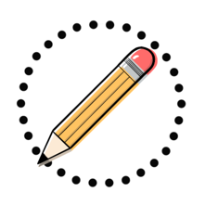
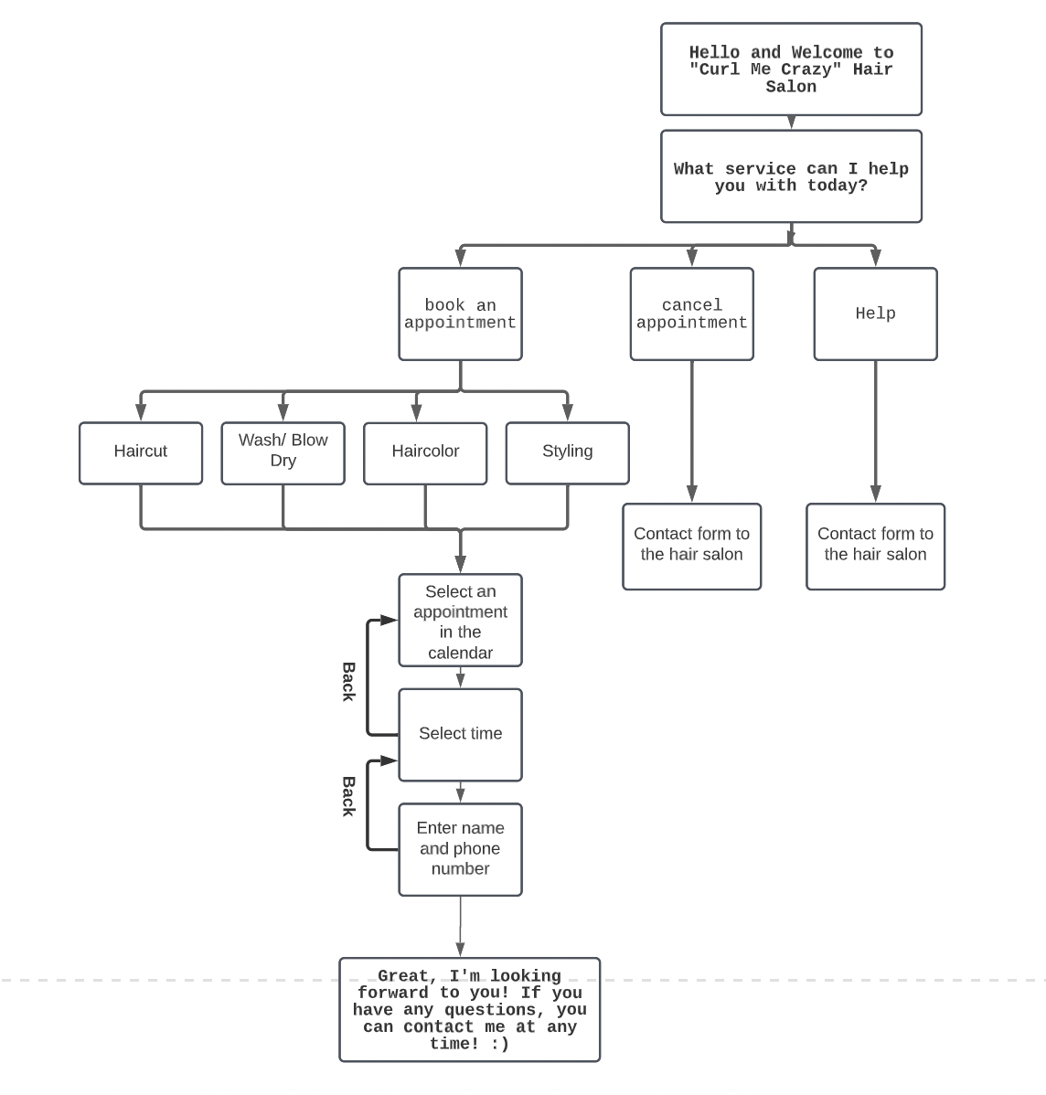
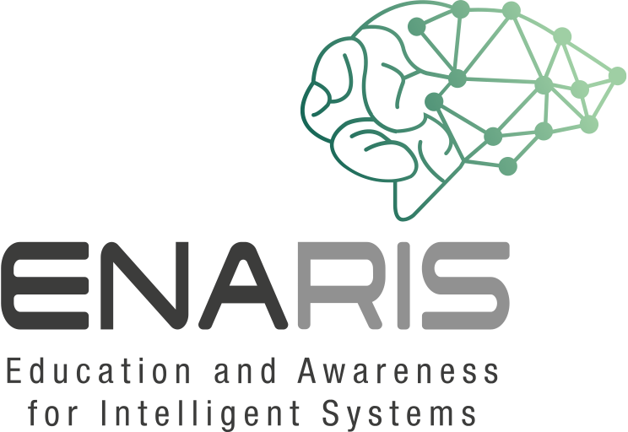
Creating a Flowchart-Based Chatbot
A possible example for a flowchart for a chatbot
In this exercise, you develop a flowchart-based chatbot using poster paper, pens,
and post-its.
Decision tree chatbots are the most unchatty kind of chatbots and are preprogrammed to follow a sequence, which can be very simple or complex. This chatbot works using pre-selected widgets with button options.
It allows you to get creative with your chatbot’s text and display options, but your user is expected to choose between these options that you define.
- Look for a topic on which the chatbot should specialize.
Do you want to be able to book a hairdressing appointment with it? Do you want to order pizza? Should he take on the role of therapist? Should he make initial diagnoses for sick people? Or do you want to calculate and manage your budget?
- Once you have decided on a type of chatbot, you must think about what tasks this chatbot should take on.
For example, a chatbot for a hair salon is designed to make appointments. What information does the chatbot need to ask for so that an appointment can be booked? (Date of the appointment, personal data such as name and telephone number, which kind of hair-service).
- In the next step you must build a flowchart where every information will be asked.

